As the new guy joining the E.W. Klein team, I’m learning a lot. The amount of technical knowledge that resides in this 100-year-old company is enormous! Speaking of being in business for 100 years, we are actually looking to update our logo to a retro version of this original old-school logo:
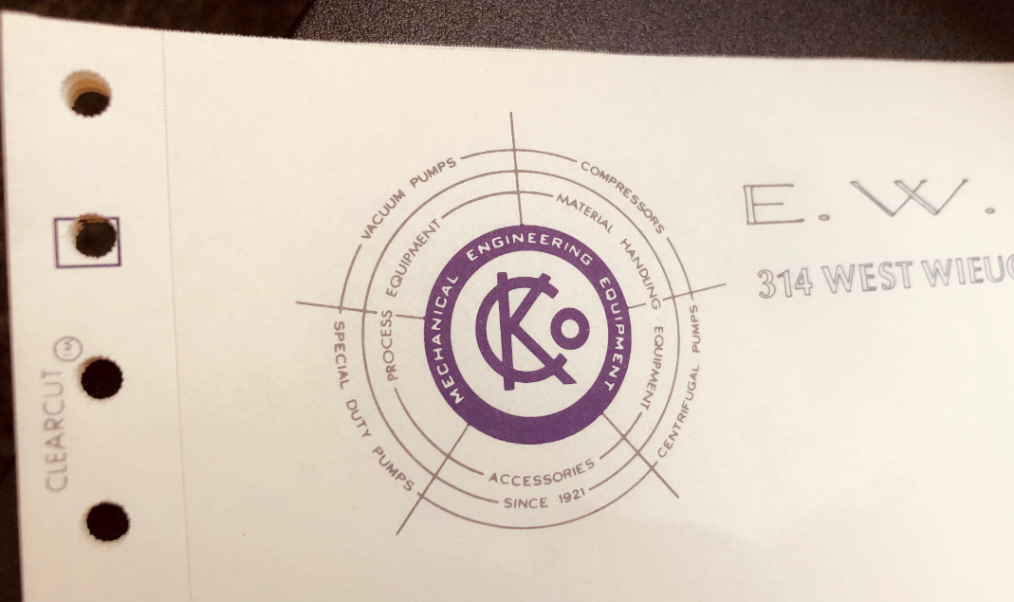
Coming from the plastics industry, I was a customer of E.W. Klein for many years, and I ran four 2AV2110 pumps in our plants in South Georgia and Normandy, France. While I have intimate knowledge of liquid ring vacuum pump technology in my previous field, I quickly found myself overwhelmed with the vast variation in vacuum applications, technical details, rule-of-thumbs, troubleshooting tips, non-standard scenarios, etc. As I’m climbing my own learning curve, I realized that I can’t be the only one that’s curious to learn and stand to benefit from these new knowledges. So, I’ve decided to package the new information I’m learning into bite size emails and documents, then share them periodically with y’all: our customers. I hope by sharing my own learning journey, you might find useful information to grow your professional knowledge and organizational wisdom.
One of the main challenges I had in my previous job with the Nash vacuum pumps centered around the plumbing between the pumps and the extruder. Clogs and leaks robbed us of critical pump capacity, until we learned to optimize the piping for proper condensation, separation, filtration, and ease of maintenance. Although we were able to stumble our way through troubleshooting vacuum issues on the extrusion line in the past, it wasn’t until recently when I was traveling with our resident paper industry veteran, Dan Dunn, did he crystalize it into this simple rule of thumb for me:
- If the gauge on the vacuum pump’s inlet is reading more vacuum than at the process, then there is probably a clog in the line.
- If the gauge on the vacuum pump’s inlet is reading the same as at the process, but are not as much vacuum as expected, then there is probably a leak.
- If the gauge on the vacuum pump inlet is reading less vacuum than at the process, then it is probably a bad gauge.
Please know that these are rules-of-thumb, which can help guide your initial troubleshooting. I’ve attached a troubleshooting guide published by Nash engineering that addresses a wider variety of common vacuum pump related issues.
As I experiment with using these emails as a communication tool with our customers, I would welcome your feedback. If you have specific questions on vacuum or heat transfer, similar experience to share, disagreement over what I’ve shared, or just don’t want to get these emails anymore, please feel free to let me know. I like to consider myself pretty thick-skinned, so I will take criticism of all kinds.
I hope you all have a productive week!

